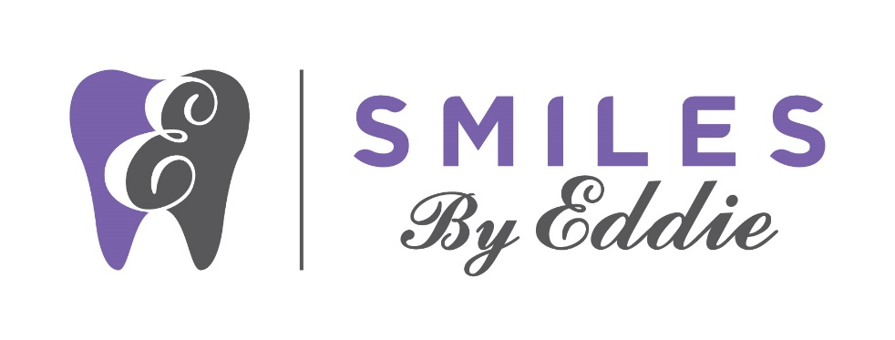

Consent for Services and Financial Policy

Thank you for choosing us as your Dental Care Provider. We are committed to your treatment being successful. Please understand that payment of your bill is considered part of your treatment. All patients must read and sign this form before seeing the doctor. As a condition of your treatment by our office, financial arrangements must be made in advance. Our practice depends upon reimbursement from the patients for the costs incurred in their care and financial responsibility on the part of each patient must be determined before treatment.
WE ACCEPT CASH, CHECKS, VISA, MASTERCARD, AMERICAN EXPRESS, DISCOVER, and CARE CREDIT.
DENTAL INSURANCE: Our office will gladly work with you to help get the maximum benefit available to you. Most dental insurance plans do not cover 100% of your treatment costs. Therefore, you will be expected to pay your deductible and your estimated co-payment on the day the services are rendered. We will gladly file your insurance claim as a courtesy. Many variables exist from carrier to carrier ( i.e. deductibles, annual maximums, allowable fee limitations, non-covered procedures and other restrictions): therefore, we cannot guarantee any estimated charges. Your policy and benefits are an agreement between you and the insurance company so ultimately you are responsible for all charges. Please know that we will do everything possible to see that you receive the full benefits from your insurance company. If for some reason your insurance company has not paid their estimated portion within 60 days from the start of treatment, you are responsible for payment in full at that time. Treatment could be altered if your dental needs change. The patient will be notified of any change(s) in treatment. We will gladly file all dental claims for any given treatment but we are not party to any insurance programs or contracts. The balance is YOUR RESPONSIBILTY whether your insurance company pays for your treatment or not. It is your responsibility to inform us of any changes in your insurance coverage.
REGARDING INSURANCE PLANS WHERE WE ARE A PARTICIPATING PROVIDER: All ESTIMATED portions and deductibles are due prior to treatment. In the event your insurance coverage changes to a plan where we are a non-participating provider, refer to above paragraph. You are responsible for advising this office if you have a change in your insurance coverage prior to your appointment.
TREATMENT PLAN ESTIMATES: We prepare TREATMENT PLAN ESTIMATES so that patients can understand their estimated cost of recommended restorative treatment prior to start. This Estimate is a good-faith attempt to predict the cost of your treatment based on the known facts when estimate is made. As your treatment progresses, your dentist may determine in consultation with you that additional or a change in treatment may be necessary and that would change the estimated cost.
USUAL AND CUSTOMARY RATES: Our practice is committed in providing the best treatment for our patients. We charge what is usual and customary for our area. You are responsible for payment regardless of any insurance company’s arbitrary determination of usual and customary rates
ADULT PATIENTS: Adult patients are responsible for full payment at time of services rendered.
MINOR PATIENTS: The adult accompanying a minor and the parents/guardians of the minor are responsible for full payment. For unaccompanied minors, non-emergency treatment will be denied unless charges have been pre-authorized to be approved by Visa, Mastercard, American Express, Discover, Care Credit, Cash or Check at the time services are rendered.
NSF CHECK POLICY AND COLLECTIONS: Payments made by check that are not honored by the bank will incur a returned check fee of $50.00. The payment will be reversed from the appropriate account when a check is returned by the bank which could result in additional fees being assed to the account. A collection letter will be sent to the account holder notifying them of the returned item and outlining the consequences of not honoring the item within 10 business days. Returned check reimbursement payments must be in the form of cash, cashier’s check, certified funds or money order. If you have a balance on your account that is past 90 days the account holder will be referred to collection agency for payment.
ASSIGNMENT OF INSURANCE BENEFITS: I understand that services rendered to me by Dr. Edmond Ahdoot, DDS, Associate Dentist, Specialist and/or Hygienist (collectively labeled as “Provider”) are my financial responsibility and that the Provider will bill my insurance company as a courtesy. I authorize my insurance company to pay my benefits directly to Provider. I understand that I will be fully responsible for any outstanding balance on my account. THIS IS A DIRECT ASSIGNMENT OF MY RIGHTS AND BENEFITS UNDER THIS POLICY. This payment will not exceed my indebtedness to the above-mentioned assignee, and I have agreed to pay, in a current manner, any balance of professional service charges over and above this insurance payment.
I have been given the opportunity to pay my estimated deductible and co-insurance at the time of service. I have chosen to assign the benefits, knowing that the claim must be paid within all state or federal prompt payment guidelines. I will provide all relevant and accurate information to facilitate the prompt payment of the claim by 25 days (electronically filed) or 45 days (paper mailed).
I authorized the provider to release any information necessary to adjudicate the claim and understand that there might be associated costs for providing information beyond what is necessary for the adjudication of a clean claim. I also authorize the provider to initiate a complaint to the insurance commissioner for any reason on my behalf.
I also understand that should my insurance company send payment to me, I will forward the payment to the Provider within 48 hours. I agree that if I fail to send the payment to the Provider and they are forced to proceed with the collections process; I will be responsible for any cost incurred by the office to retrieve their monies. In the event Patient receives any check, draft, or other payment subject to this agreement, I will immediately deliver said check, draft, or other payment to Provider. Any violations of this agreement will, at Provider’s election, terminate Patient charge privileges with Provider and bring any balance owed by Patient to Provider immediately due and payable.
I authorize the dentist to release any information including the diagnosis and the records of any treatment or examination rendered to me or my child during the period of such dental care to third party payers and/or healthcare practitioners.
I grant my permission to you or your assignee, to telephone me at home, my work, or my cell phone to discuss matters related to this form. I agree to have any photos taken of me to be used for education, training and/or marketing. I have read the above conditions of treatment and payment and agree to the contents.
_____________________________________ Date: ________________
Printed Patient Name

__________________________________________
Signature of Patient

